Name : Utari Isnawati

NIM : L200174074

Class : X

**Laporan Praktikum Pemrograman Web Dinamis**

**Modul 4**

**Percobaan 1**

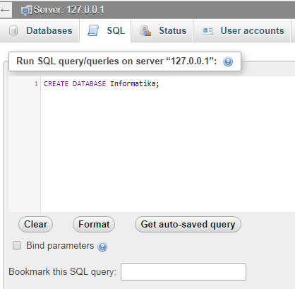

**Percobaan 2**

Query :

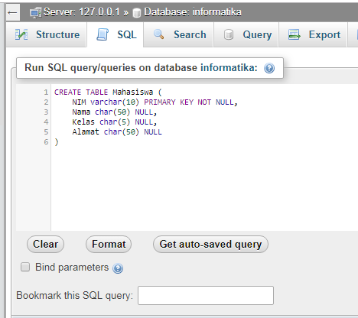

Result :

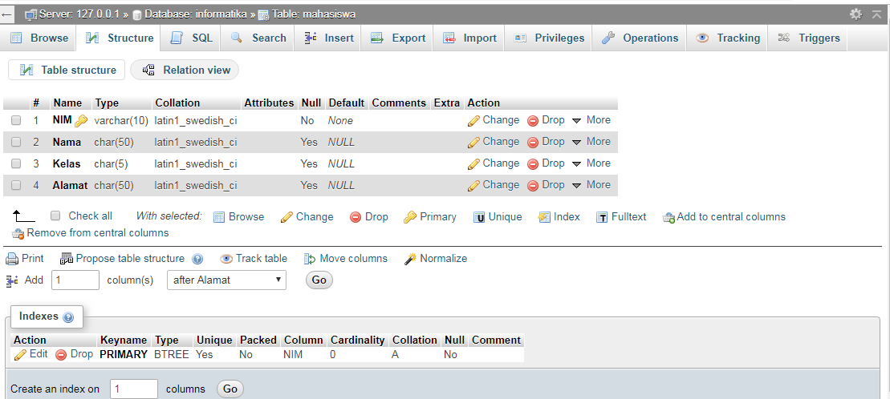

**Percobaan 3**

Query :

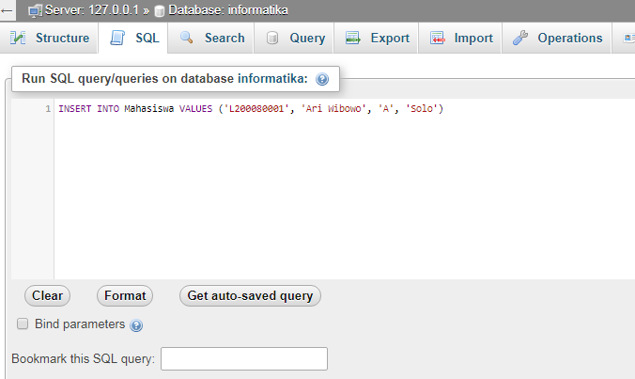

Result :

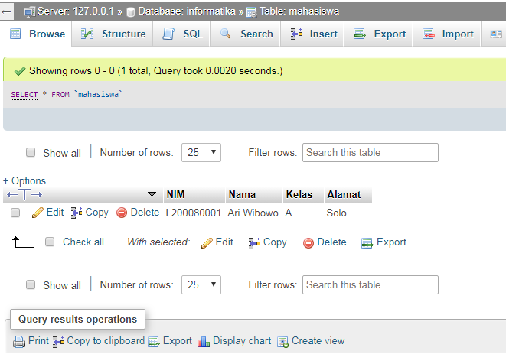

Query :

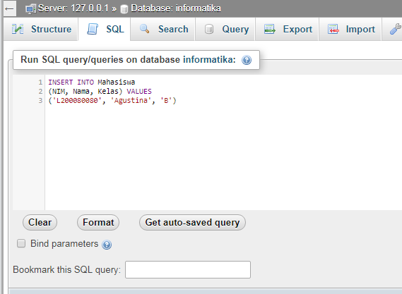

Result :

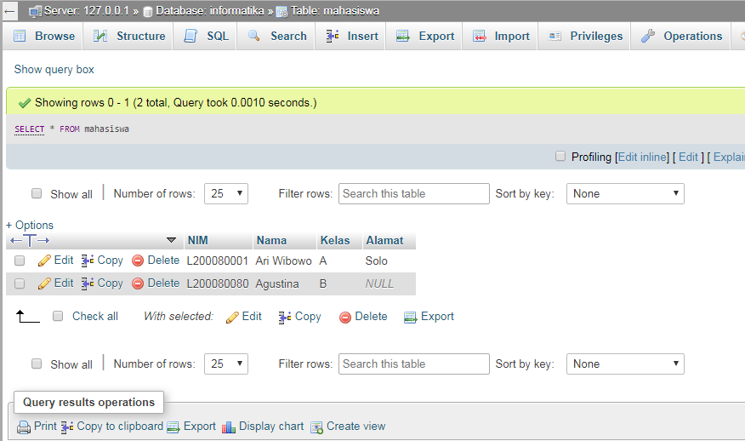

**Percobaan 4**

Query :

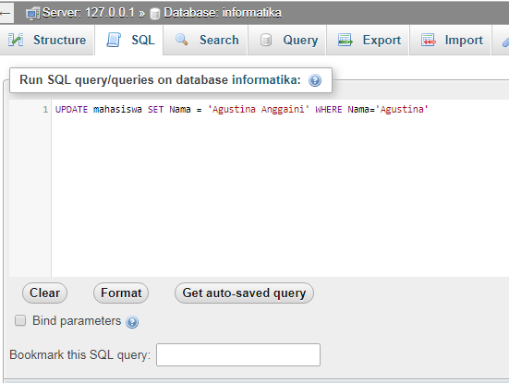

Result :

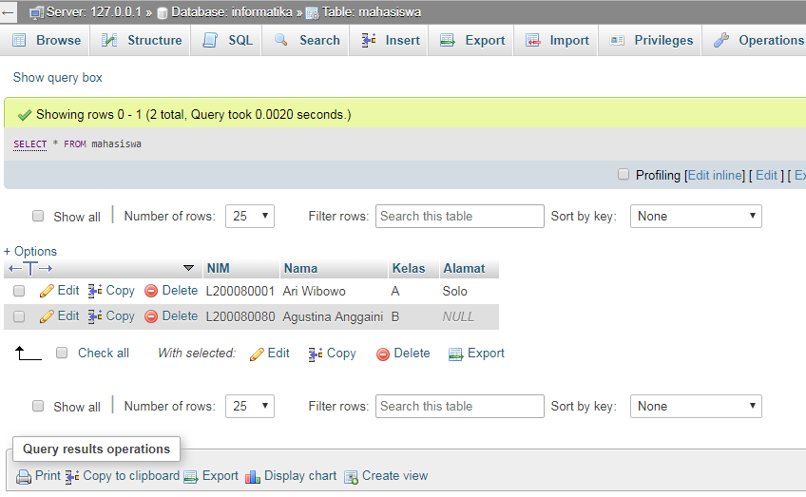

**Make data to JOIN the data**

Query :

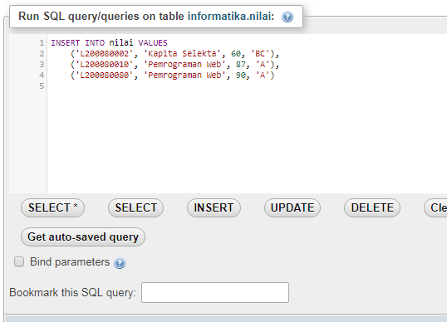

Result :

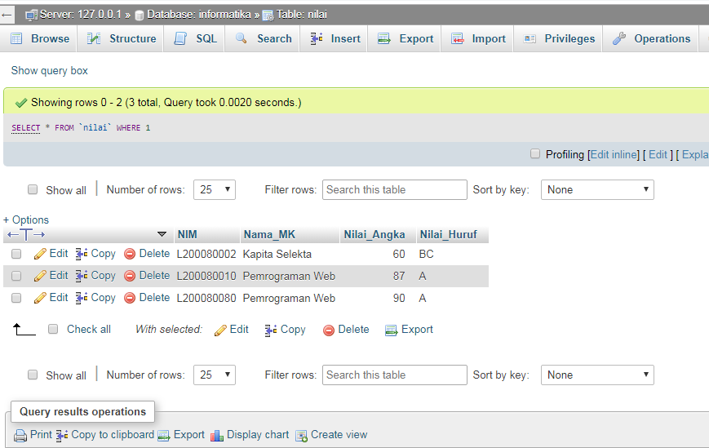

**Percobaan 5**

Query :

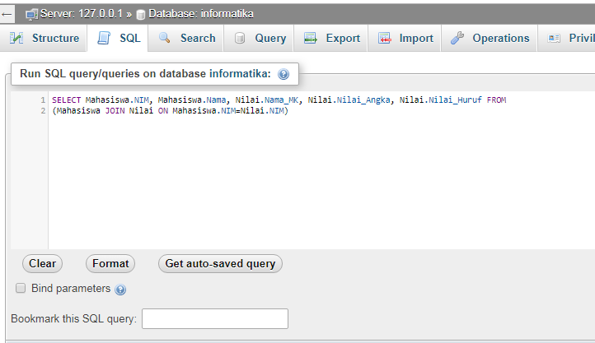

Result :

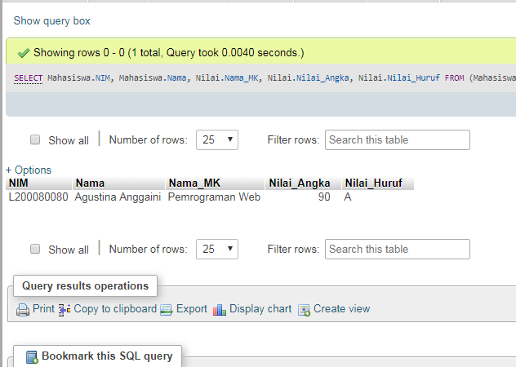

**Percobaan 6**

Query :

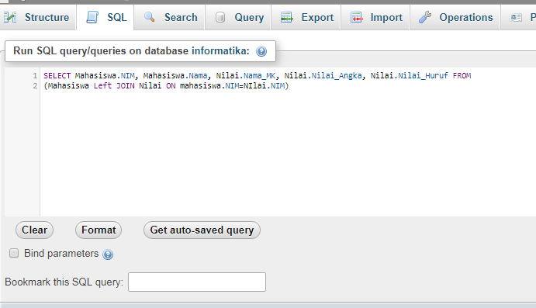

Result :

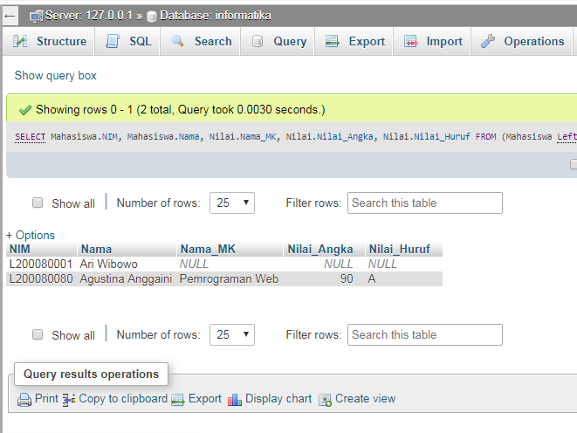

**Percobaan 7**

Query :

SELECT Mahasiswa.NIM, Mahasiswa.Nama, Nilai.Nama_MK, Nilai.Nilai_Angka, Nilai.Nilai_Huruf FROM (Mahasiswa RIGHT JOIN Nilai ON Mahasiswa.NIM=Nilai.NIM)

Result :

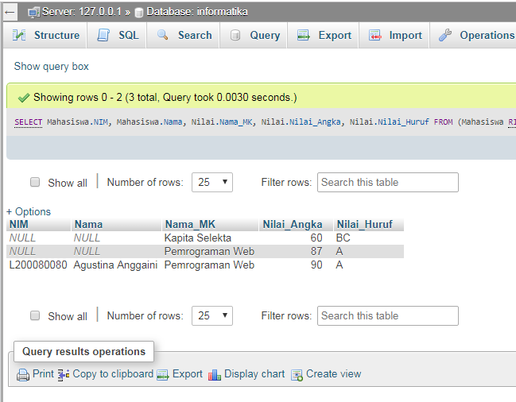

**Percobaan 8**

Query :

SELECT AVG(Nilai_Angka) 'Rata-rata Nilai' FROM Nilai

Result :

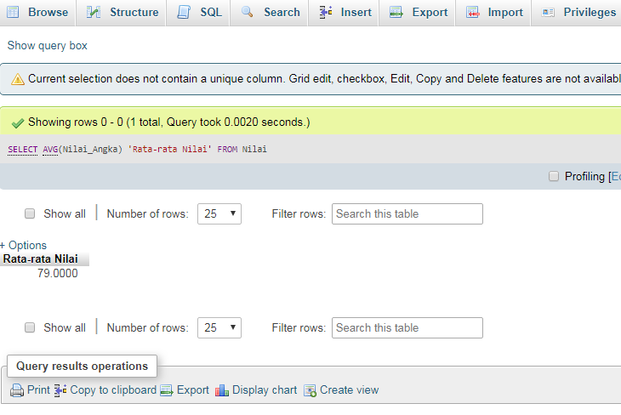

**Percobaan 9**

Query :

SELECT SUM(Nilai_Angka) 'Total Nila' FROM Nilai

Result :

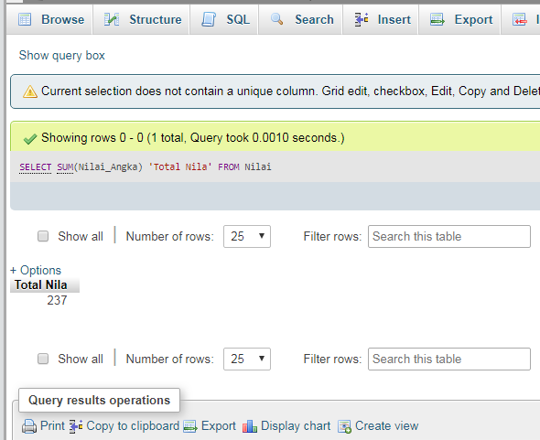

**Percobaan 10**

Query :

CREATE VIEW KHS AS SELECT Mahasiswa.NIM, Nilai.Nama_MK, Nilai.Nilai_Angka, Nilai.Nilai_Huruf FROM

(Mahasiswa INNER JOIN Nilai ON Mahasiswa.NIM=Nilai.NIM)

Result :

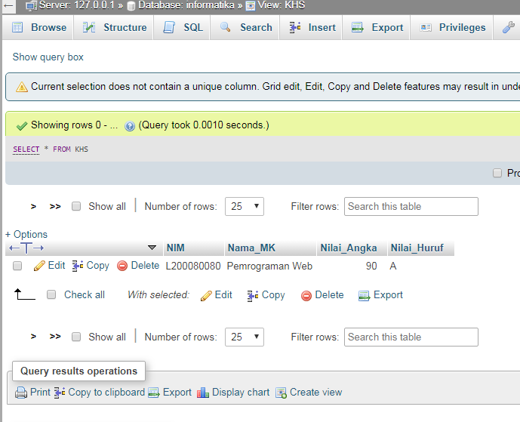

**TUGAS.**

1. **Function of syntax query in database.**

|  |  |
| --- | --- |
| **QUERY** | **FUNCTION** |
| SELECT | Return data stored in the database |
| JOIN | Combines [columns](https://en.wikipedia.org/wiki/Column_(database)) from one or more [tables](https://en.wikipedia.org/wiki/Table_(database)) in a relational [database](https://en.wikipedia.org/wiki/Database). |
| LEFT JOIN | Returns all rows from the left table and the matching rows from the right table |
| RIGHT JOIN | Returns all rows from the right table, even if there are no matches in the left table |
| AVG | Returns the average value of a group. |
| SUM | To calculate the sum of values. |

1. **Syntaks SQL to update the data of address from mahasiswa that have NIM L20008080.**

UPDATE Mahasiswa SET Alamat = 'Sragen' WHERE NIM = 'L20008080'

